# **Lab 4: Advanced Prompt Engineering – Zero-shot, One-shot, and Few-shot Techniques**

# Assignment 1

**Name:CHADA SATHWIKA**

**HTNO:2403a51334**

**BTNO:24BTCAICSB14**

**Task1:**

**Prompt:** "Write a function in Python that validates an Indian mobile number. The function should return True if the number meets both of the following conditions: (1) it starts with 6, 7, 8, or 9, and (2) it contains exactly 10 digits. Otherwise, it should return False."

**CODE:**

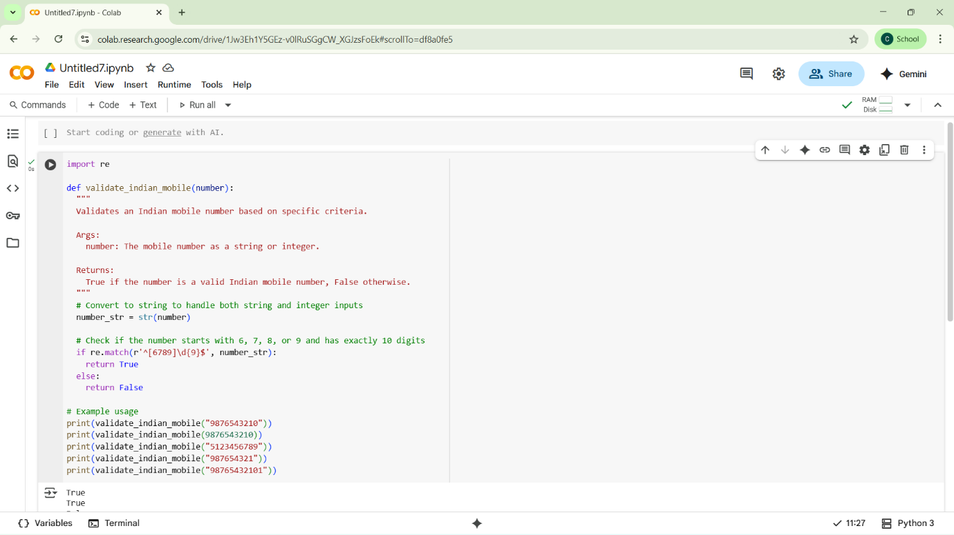

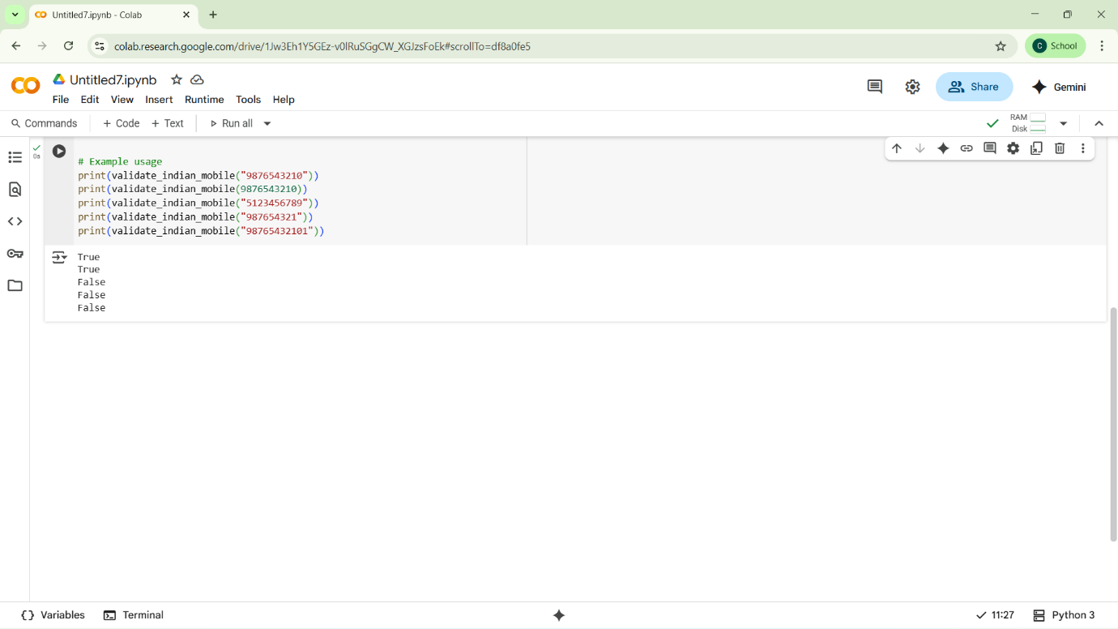

**TASK 2**

**Prompt: "**Write a Python function that calculates the factorial of a number. The function should return 1 for an input of 0, and return an appropriate message like 'Factorial is not defined for negative numbers' if the input is negative. For example, if the input is 5, the output should be 120."

**CODE:** 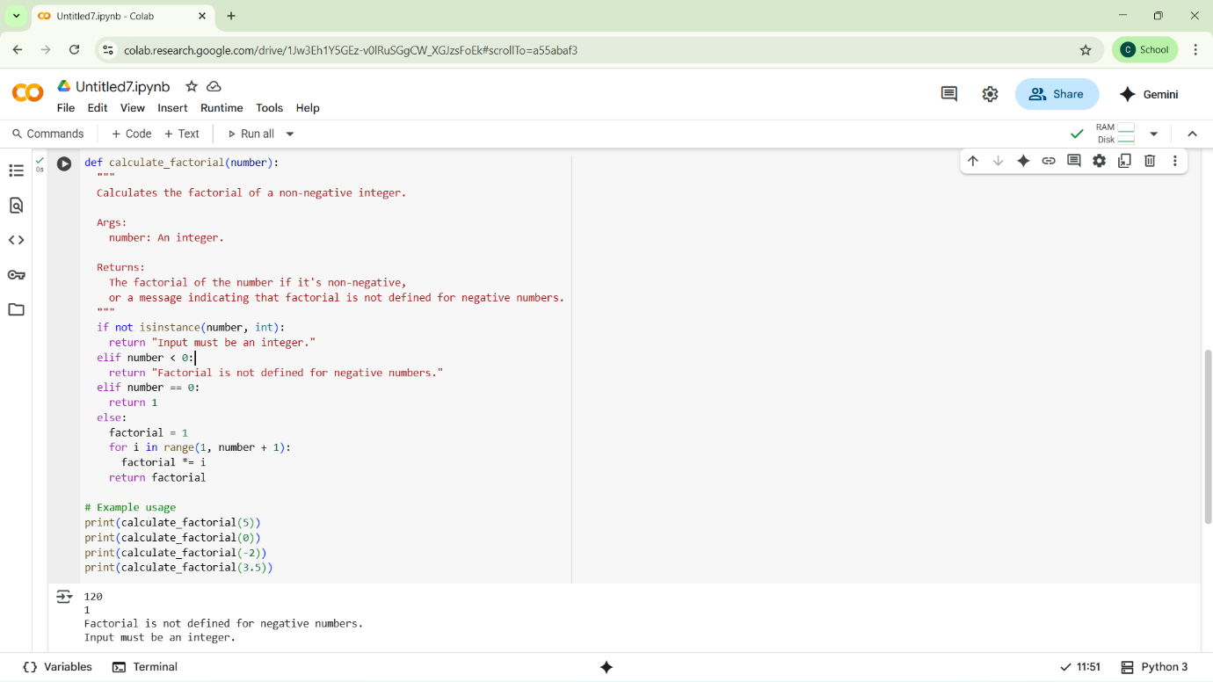

**TASK:3**

**PROMPT:** "Write a Python function that takes a nested dictionary containing student information and extracts the student's full name, branch, and SGPA. Return these values as a tuple.

Example 1: Input

student = {

'personal': {'first_name': 'Amit', 'last_name': 'Verma'},

'academic': {'branch': 'CSE', 'SGPA': 8.7}

}

Output: ('Amit Verma', 'CSE', 8.7)

Example 2: Input:

python

student = {

'personal': {'first_name': 'Sneha', 'last_name': 'Reddy'},

'academic': {'branch': 'ECE', 'SGPA': 9.1}

}

Output: ('Sneha Reddy', 'ECE', 9.1)

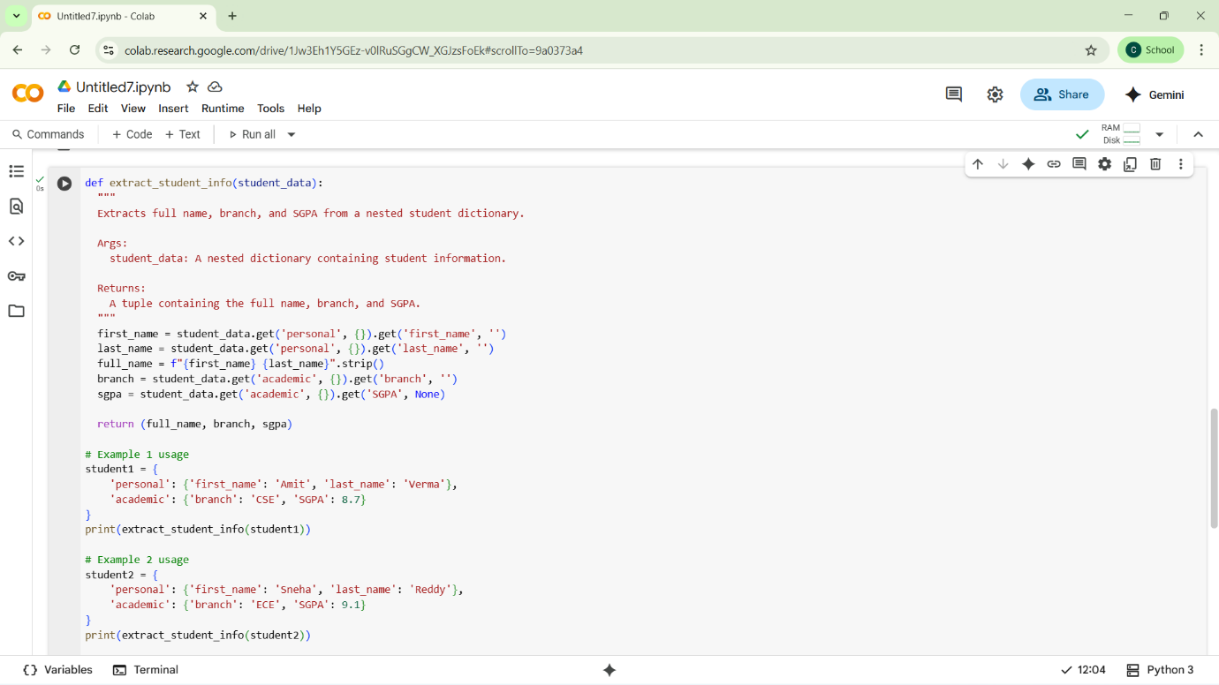

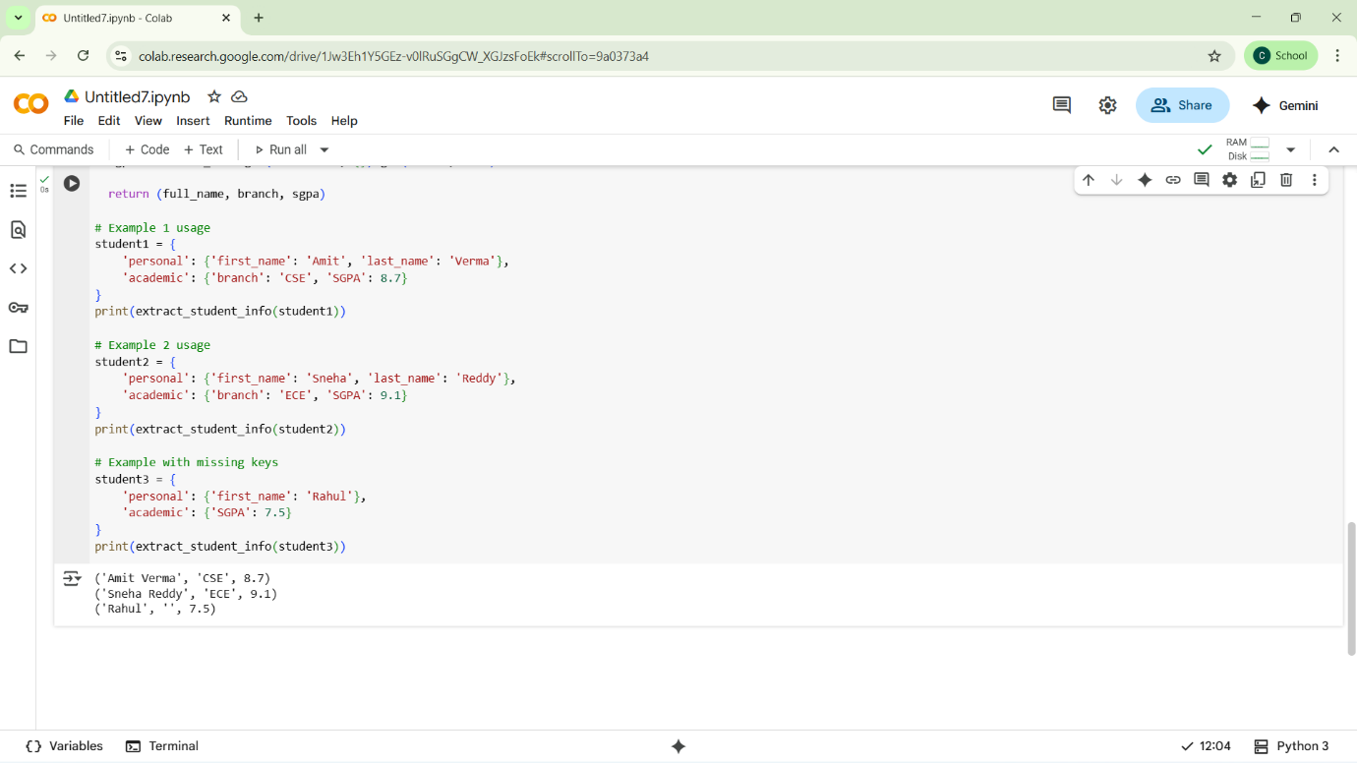

**TASK 4:**

**Prompt:** Generate three Python functions using different prompting styles to analyze a .csv file. Each function should:

* Read the .csv file
* Return the total number of rows
* Count the number of empty rows
* Count the total number of words across the file

Use the following prompting styles:

1. Zero-Shot Prompt: Write the function based only on the task description above, without any examples.

2. One-Shot Prompt: Include one input-output example to guide the function. Example: File contents:

Name,Age

Alice,30

Bob,25

,

Charlie,22

Output: (5, 1, 8)

3. Few-Shot Prompt: Include two input-output examples to guide the function. Example 1: File contents:

Name,Age

Alice,30

Bob,25

,

Charlie,22

Output: (5, 1, 8)

Example 2: File contents:

Product,Price

Laptop,1000

Phone,500

Tablet,

,

Output: (5, 2, 8)

Generate all three functions accordingly."

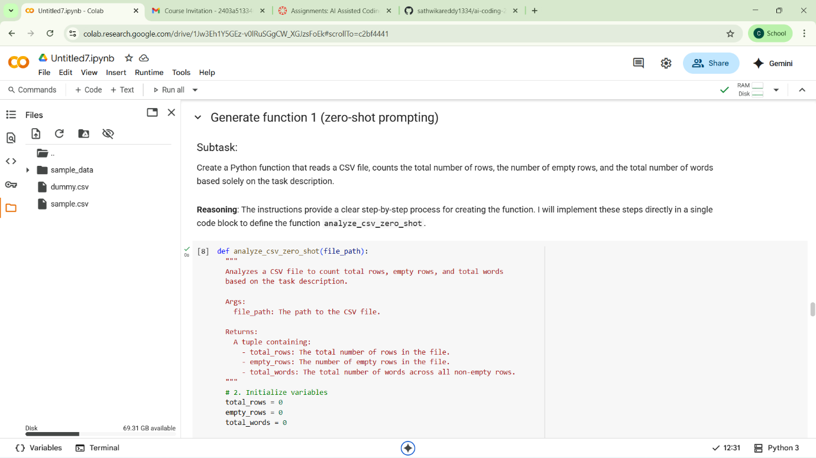

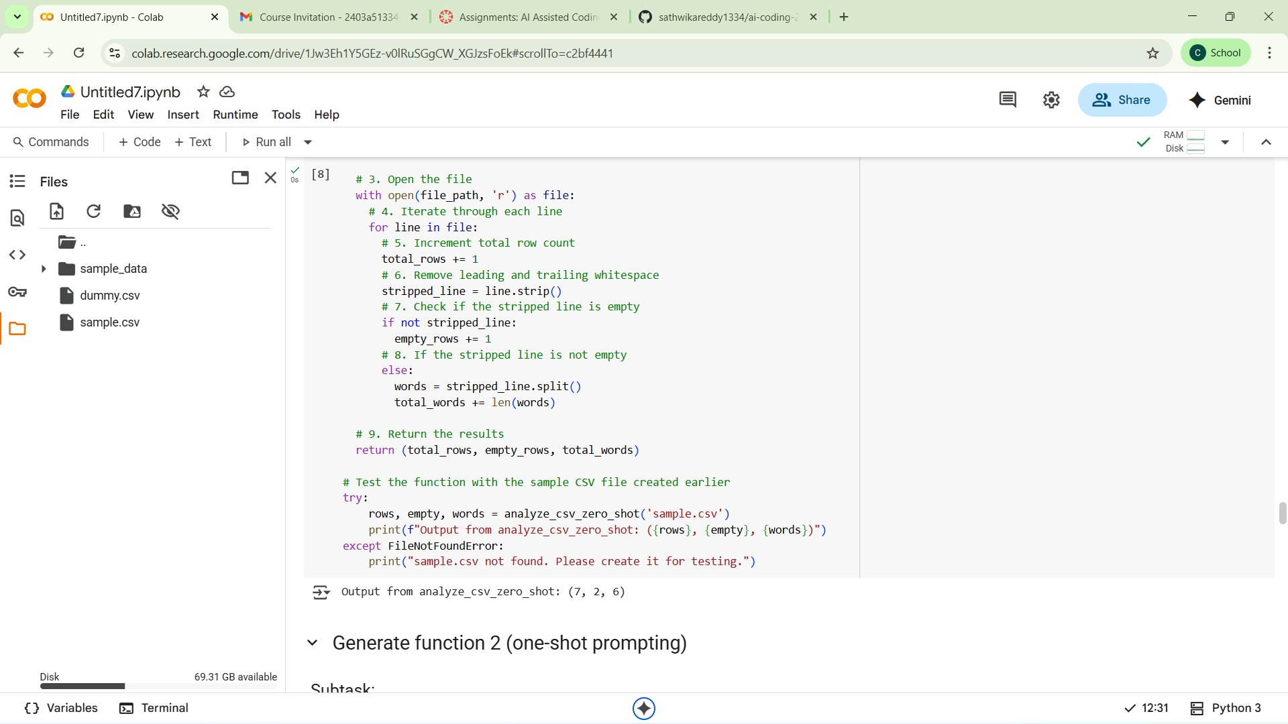

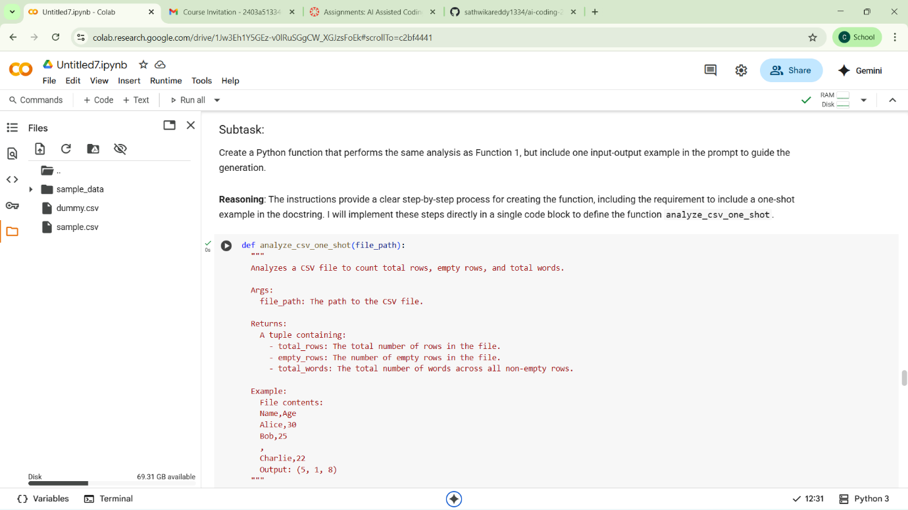

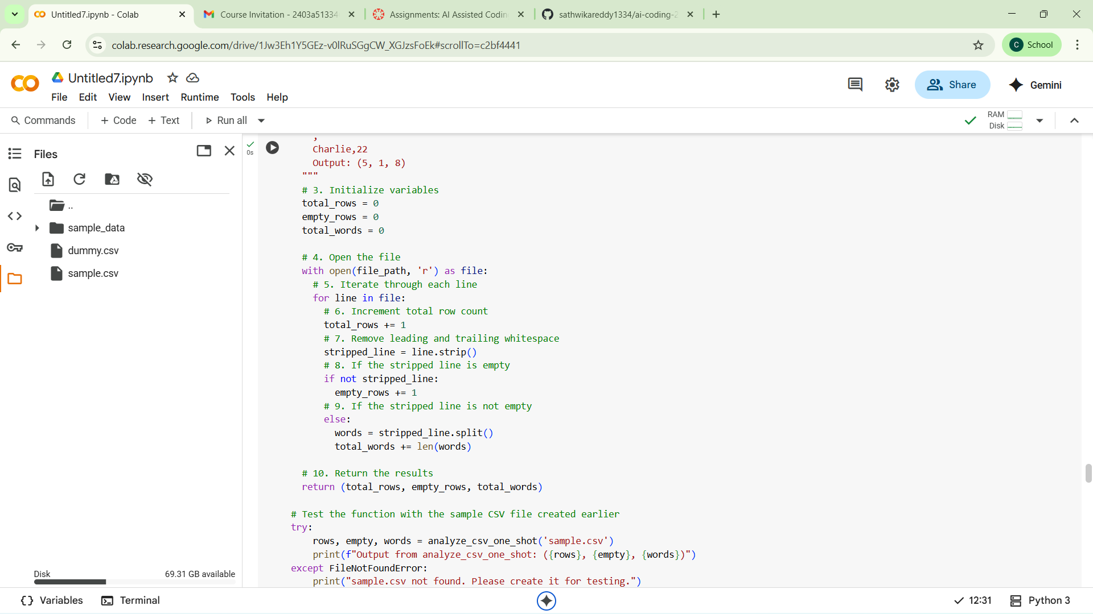

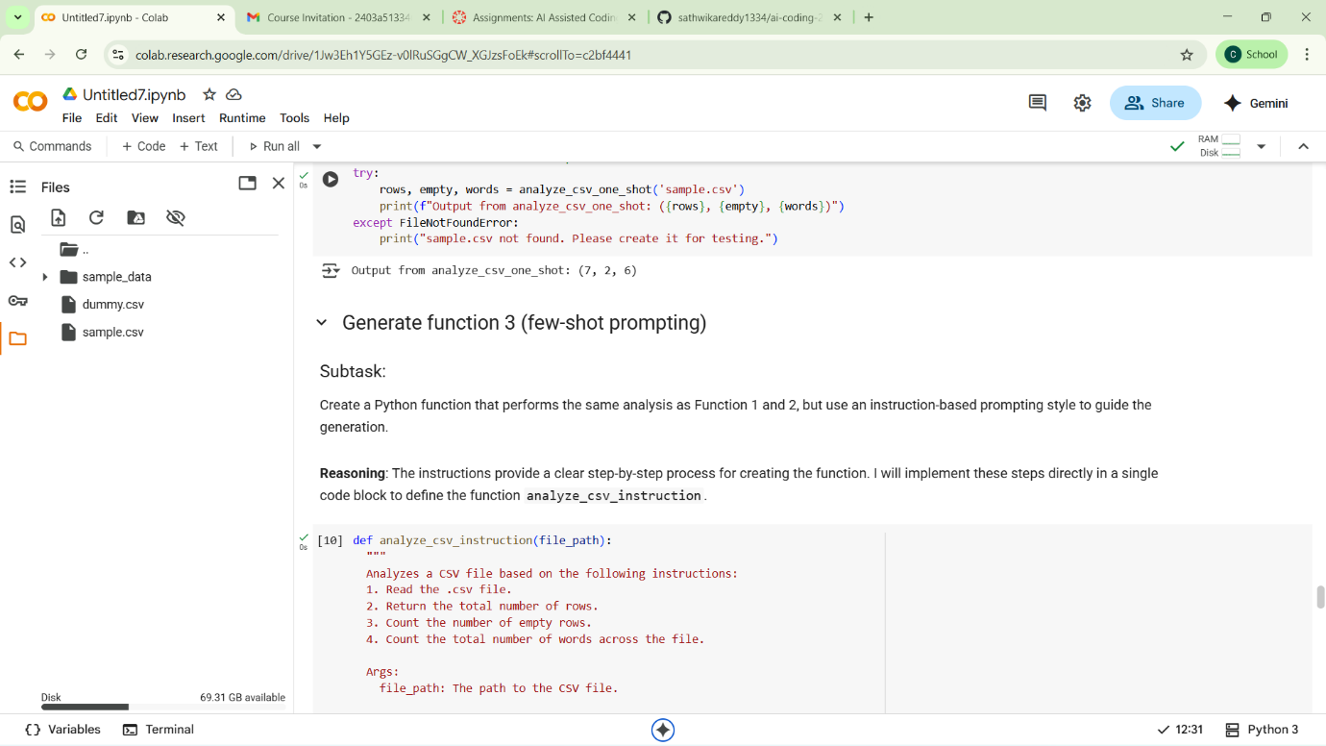

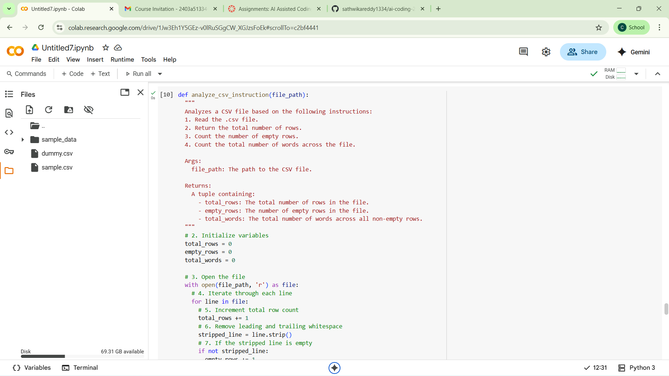

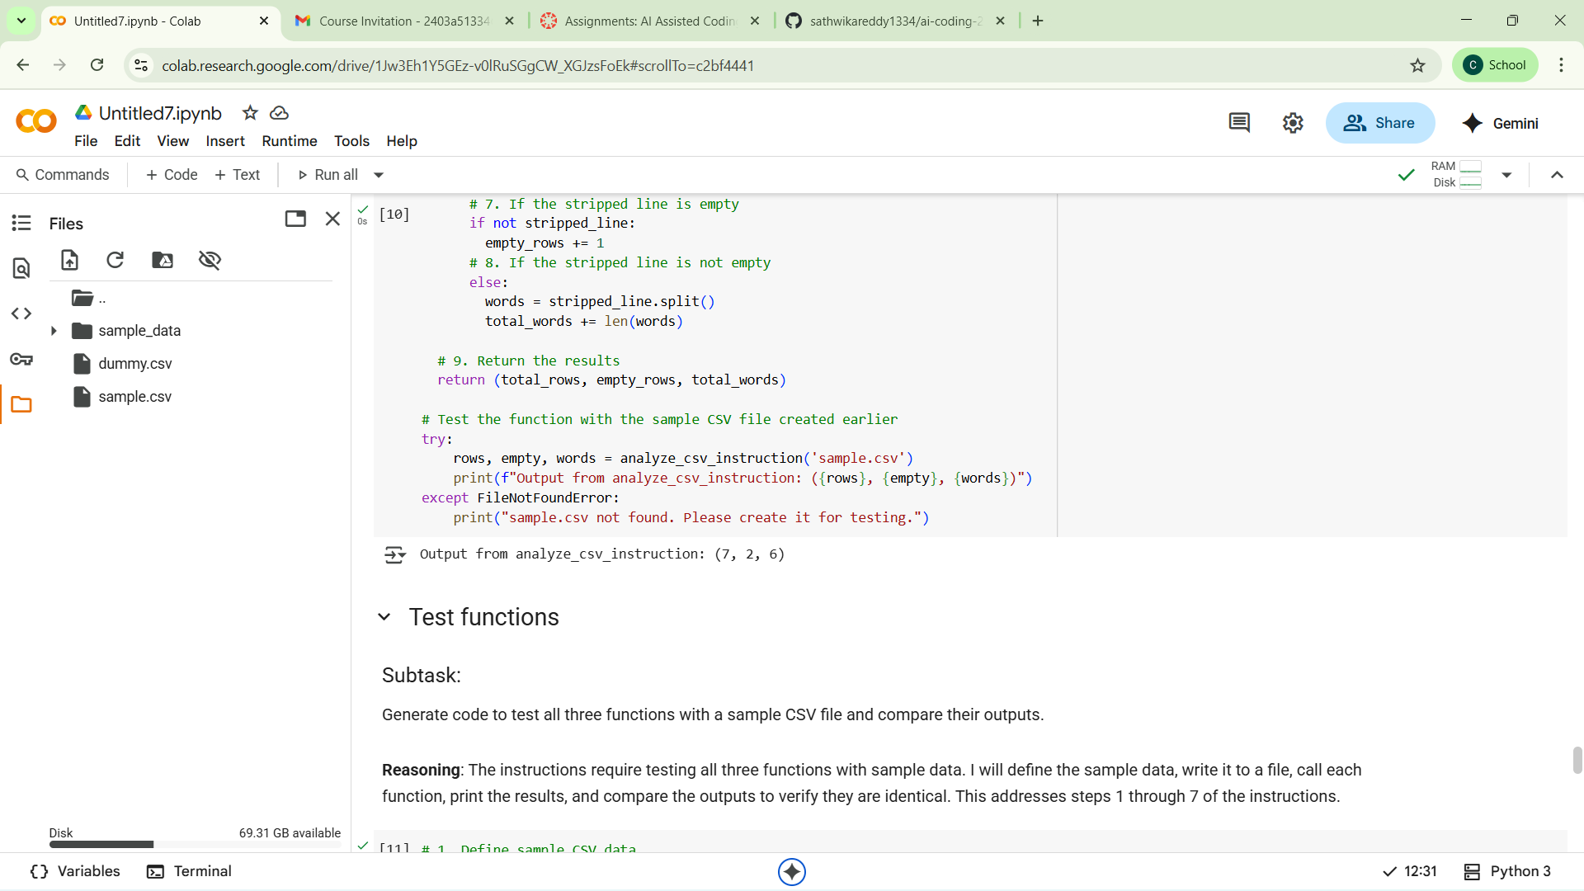

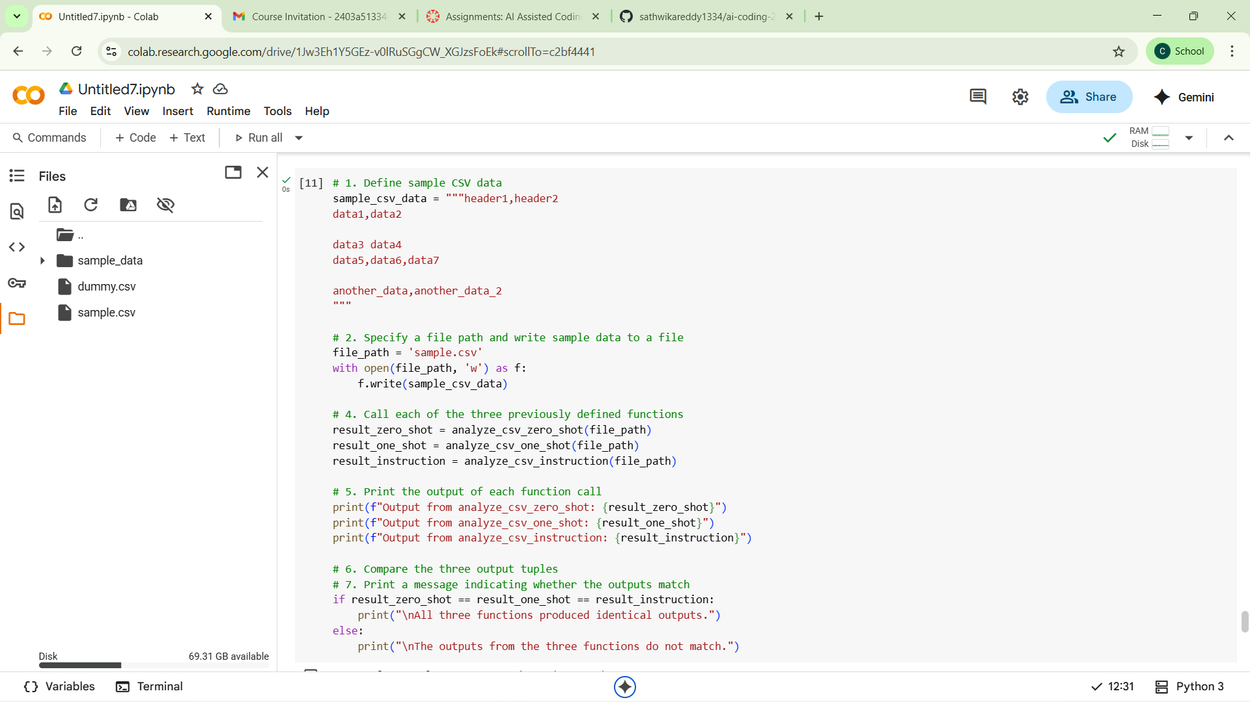

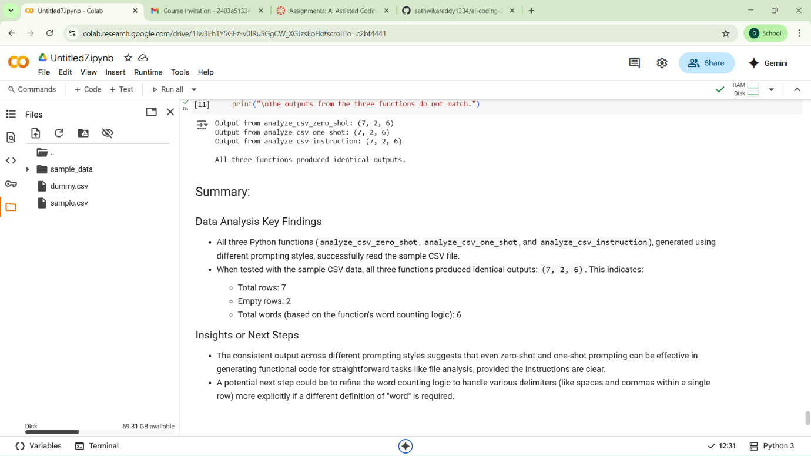

**TASK 5:**

**Prompt: "**Write a Python function that accepts a paragraph of text and returns the most frequently used word. The function must:

* Convert all text to lowercase
* Remove all punctuation
* Count word frequency
* Return the word with the highest frequency

Use the following examples to guide your implementation:

Example 1: Input: "Hello world! Hello again." Output: "hello"

Example 2: Input: "Python is great. Python is dynamic. Python is powerful." Output: "python"

